Chapter 7
SYSTEM STUDY & TESTING

7.1 FEASIBILITY STUDY
The feasibility of the HygionX system is analyzed to ensure that the proposed AI-based medical triage application is practical, efficient, and beneficial for users. This study evaluates whether the system can be developed and deployed without excessive resource demands while delivering meaningful healthcare guidance.

The feasibility analysis considers the following key aspects:
- Technical Feasibility
- Social Feasibility
- Economical Feasibility

- Technical Feasibility
This study evaluates whether the required technology and resources are available to develop and run the system efficiently.
The HygionX system is technically feasible as it is built using widely adopted and scalable technologies such as Flask, Firebase Authentication, SQLAlchemy, and machine learning components.
- The system supports both ML-assisted mode and fallback rule-based mode, ensuring reliability even when advanced models are unavailable.
- It does not require high-end hardware and can run on standard web servers.
- The modular architecture enables smooth integration between frontend, backend, and AI components.
- The system is designed to be scalable and maintainable for future enhancements.
Thus, the system has moderate technical requirements and can be implemented effectively.

- Social Feasibility
This aspect evaluates the level of acceptance of the system among users.
HygionX is designed to be user-friendly and accessible, ensuring high acceptance among users. The system can be easily accessed through standard web browsers without requiring installation or technical expertise, making it convenient for a wide range of users.
- The chat-based interface allows users to describe symptoms naturally.
- The system provides clear explanations, risk levels, and recommendations, improving user trust.
- Safety disclaimers are included to ensure users understand that it is not a replacement for professional medical advice.
- Minimal training is required due to the intuitive interface.
Hence, the system is socially acceptable and easy to adopt.

- Economic Feasibility
This study evaluates the cost-effectiveness of the system.
The HygionX system is economically feasible as it utilizes mostly open-source and freely available technologies. Additionally, the system requires minimal maintenance and operational costs, making it financially sustainable in the long run.
- Technologies such as Flask and Python libraries are open-source.
- Firebase provides scalable authentication with a free tier.
- Deployment and maintenance costs are relatively low.
- The system can scale gradually without significant additional cost.

Additionally, the system provides indirect economic benefits:
- Reduces unnecessary hospital visits for minor conditions
- Saves time for both users and healthcare providers
- Provides quick preliminary guidance, improving efficiency
Thus, the system is cost-effective and financially viable.

7.2 SOFTWARE TESTING
The purpose of testing is to identify errors and ensure that the HygionX system functions correctly, efficiently, and safely. Testing verifies that the system meets user requirements and provides reliable medical guidance. In addition to validating correctness, testing in HygionX focuses on ensuring continuity of conversation, accurate symptom interpretation, proper urgency classification, and smooth interaction between system components.
There are various types of tests. Each type of test address a specific testing requirement.

Types of Testing:
- Unit Testing
- IntegrationTesting
- System Testing
- Performance Testing
- Acceptance Testing

- Unit Testing:
Unit testing involves verifying individual components of the system in isolation to ensure that each module performs its intended function correctly. This type of testing is carried out during the development phase and focuses on validating internal logic and data processing.
In HygionX, unit testing is applied to critical components such as:
- Symptom extraction modules, including both machine learning-based and rule-based fallback approaches
- Severity scoring algorithms that compute risk levels based on detected symptoms
- Emergency detection logic that identifies high-risk conditions
- API endpoints and backend utility functions
Each unit is tested with multiple input scenarios, including valid, invalid, and edge-case inputs, to ensure robustness. Unit testing helps detect errors early, reduces debugging effort in later stages, and ensures a strong foundation for integration.

Test Case ID | Input | Function | Expected Output | Result
UT-01 | "I am suffering from fever and headache” | Symptom Extraction | ["fever", "headache"] | Passed
UT-02 | Symptoms list | Severity Scoring | Score between  1–10 | Passed
UT-03 | Chest pain | Urgency Detection | “Emergency” | Passed
UT-04 | API Health request | EndpointValidation | Status OK | Passed
Table 7.2.1 : Unit Testing
- Integration Testing:
Integration testing evaluates the interaction between different modules of the system to ensure that they work together seamlessly. While individual components may function correctly on their own, integration testing verifies that combined modules exchange data properly and produce correct results.
In HygionX, integration testing focuses on:
- Communication between the frontend user interface and backend APIs
- Interaction between the chat API and the triage engine
- Authentication and session management using Firebase
This testing ensures that user inputs are correctly transmitted, processed, and stored, and the responses generated by system are accurate and consistent across modules.
Test Case ID | Module Interaction | Input | Expected Output | Result
IT-01 | Chat UI => API | User message | Valid structured response returned | Passed
IT-02 | API =>Triage Engine | Symptoms text | Follow-up or final assessment generated | Passed
IT-03 | Triage Engine => Database | Final result | Stored successfully | Passed
IT-04 | Authentication => Backend | Valid Token | User Authenticated Successfully | Passed
Table 7.2.2 : Integration Testing

- System Testing:
System testing evaluates the complete HygionX application as a fully integrated system. It ensures that all components work together correctly and that the system behaves as expected in real-world scenarios.
This testing phase includes:
- End-to-end validation of the chat-based triage workflow
- Verification of multi-turn conversations and context retention
- Testing of emergency detection and escalation mechanisms
- Evaluation of system responses for both typical and edge-case inputs
- Verification of user interface behavior and clarity of displayed results
System testing simulates real user interactions and helps identify issues related to overall system functionality, usability, and stability.
Test Case ID | Scenario Description | Input Provided | Expected System Behaviour | Result
ST-01 | User enters multiple symptoms in a single message | "I have fever, headache and nausea" | System extracts all symptoms and generates relevant follow-up questions | Passed
ST-02 | User provides emergency-related symptoms | "I have severe chest pain and difficulty breathing" | System immediately classifies as emergency and displays urgent medical advice | Passed
ST-03 | User enters mild/common symptoms | "I have a mild cough and cold" | System classifies as low/moderate risk and provides guidance | Passed
ST-04 | User provides incomplete or vague input | "I feel unwell" | System asks clarification questions to gather more details | Passed
ST-05 | User enters invalid or unrelated input | Random text or empty input | System handles without crashing and prompts user again | Passed
ST-06 | Multi-turn conversation scenario | Sequential symptom inputs across messages | System retains previous context and refines assessment | Passed
ST-07 | User reaches maximum follow-up limit | Multiple incomplete responses across turns | System stops follow-ups and generates final assessment | Passed
Table 7.2.3 : System Testing

- Performance Testing:
Performance testing evaluates the responsiveness, scalability, and stability of the HygionX system under varying workloads and conditions. Since the system is developed in a local environment and not deployed for real-world usage, performance testing is conducted by simulating concurrent user interactions.
In HygionX, performance testing includes:
- Measuring response time of the chat API for different types of inputs
- Simulating multiple concurrent requests using browser sessions and repeated API calls
- Evaluating system behavior under continuous and rapid request conditions
- Identifying potential bottlenecks in processing or data handling
Performance testing was conducted in a controlled local environment by simulating concurrent usage through multiple browser instances and repeated requests to the backend. This approach helps ensure that the system remains responsive and stable even under increased load conditions.

Test Case ID | Scenario | Input Provided | Expected Output | Result
PT-01 | Simulated concurrent requests | Multiple parallel requests to chat API | Response time < 2 seconds | Passed
PT-02 | Continuous request handling | Repeated API calls over time | No system crash or performance degradation | Passed
PT-03 | Large input processing | Long symptom descriptions | System processes input without delay or failure | Passed
PT-04 | LLM response handling | Complex symptom input requiring detailed analysis | System generates response within acceptable time without timeout | Passed
Table 7.2.4 : Performance Testing

- Acceptance Testing:
Acceptance testing is the final phase of testing, where the system is evaluated from the user’s perspective to determine whether it meets the specified requirements and expectations. This testing ensures that the system is ready for deployment.
In HygionX, acceptance testing focuses on:
- Usability and ease of interaction with the chat interface
- Clarity and usefulness of the medical guidance provided
- Accuracy of symptom-based triage results
- Overall user satisfaction and experience
This phase may involve feedback from test users, helping to identify any remaining issues or improvements before final deployment.

Test Case ID | Criteria | Expected Behaviour | Result
AT-01 | Basic symptom input | Clear triage result displayed | Passed
AT-02 | Follow-up interaction | Logical questions asked | Passed
AT-03 | Emergency case | Immediate warning displayed | Passed
AT-04 | UI clarity | Results displayed clearly | Passed
AT-05 | User experience | Smooth and intuitive interaction | Passed
AT-06 | Display of confidence score | System displays confidence score clearly along with assessment | Passed
Table 7.2.5 : Acceptance Testing

Chapter 8
SOURCE CODE

Chapter 9
SCREEN LAYOUTS

9.1 INTERFACE LAYOUT
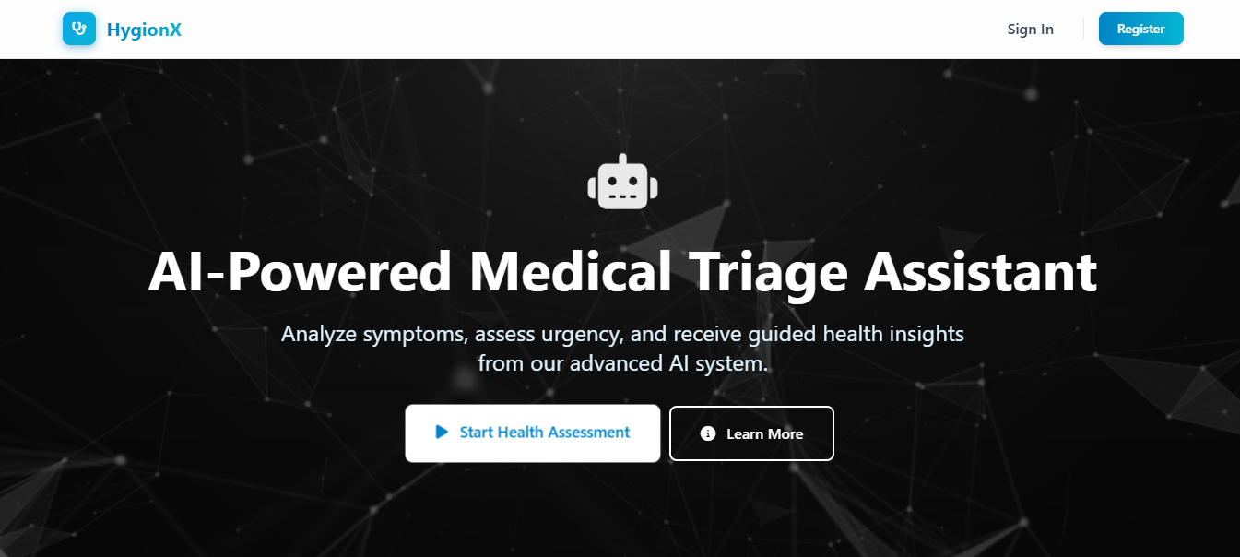
Fig 9.1.1 : Landing Page

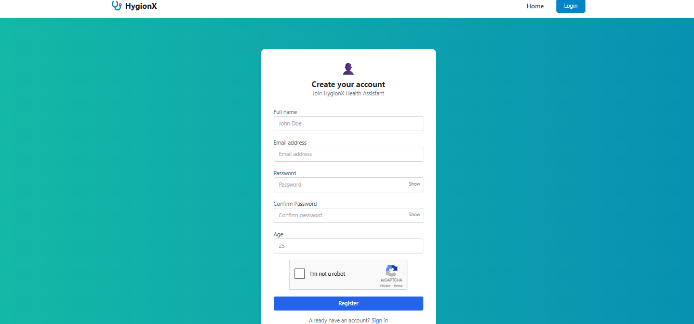
Fig 9.1.2 : Authentication Interface

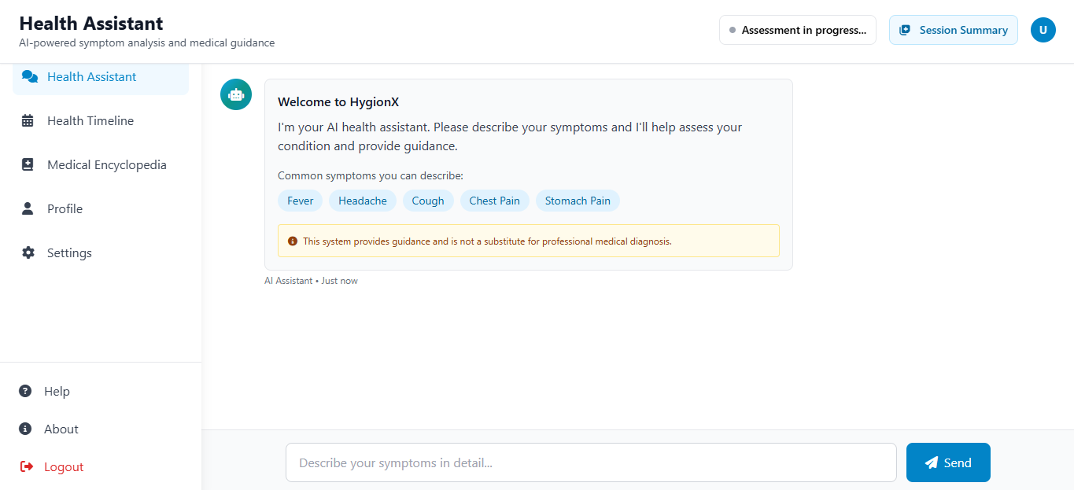
Fig 9.1.3 : Health Assistant Interface

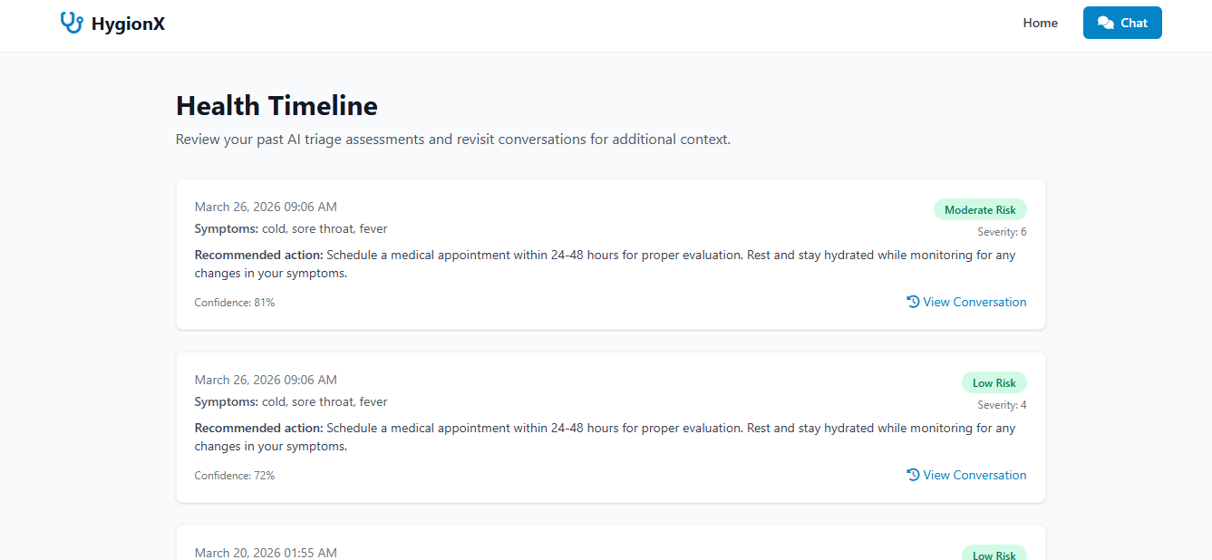
Fig 9.1.4 : Health Timeline Interface

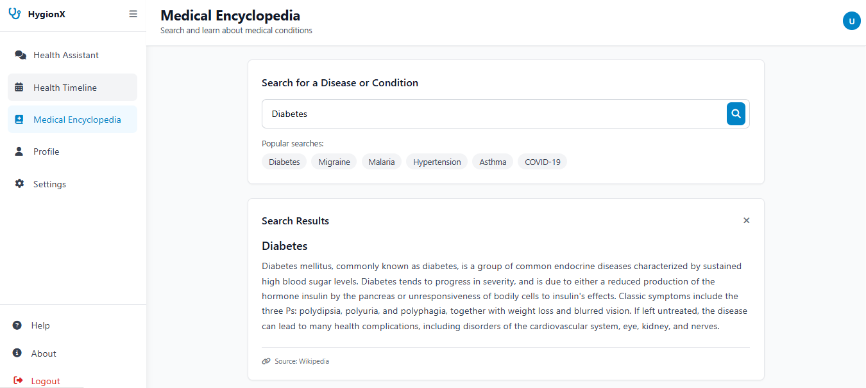
Fig 9.1.5 : Medical Encyclopedia Interface

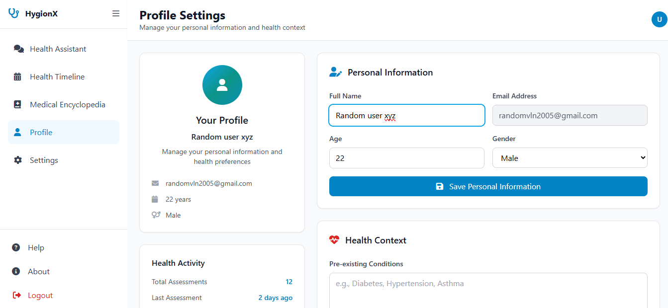
Fig 9.1.6 : Profile Interface

9.2 RESULTS

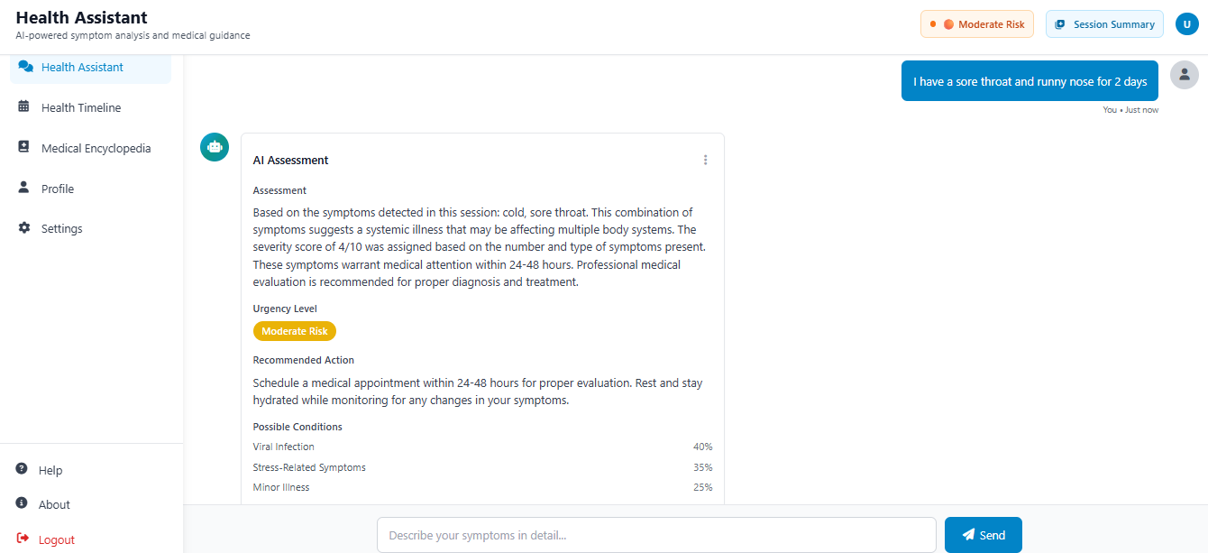
Fig 9.2.1 : Chat Output
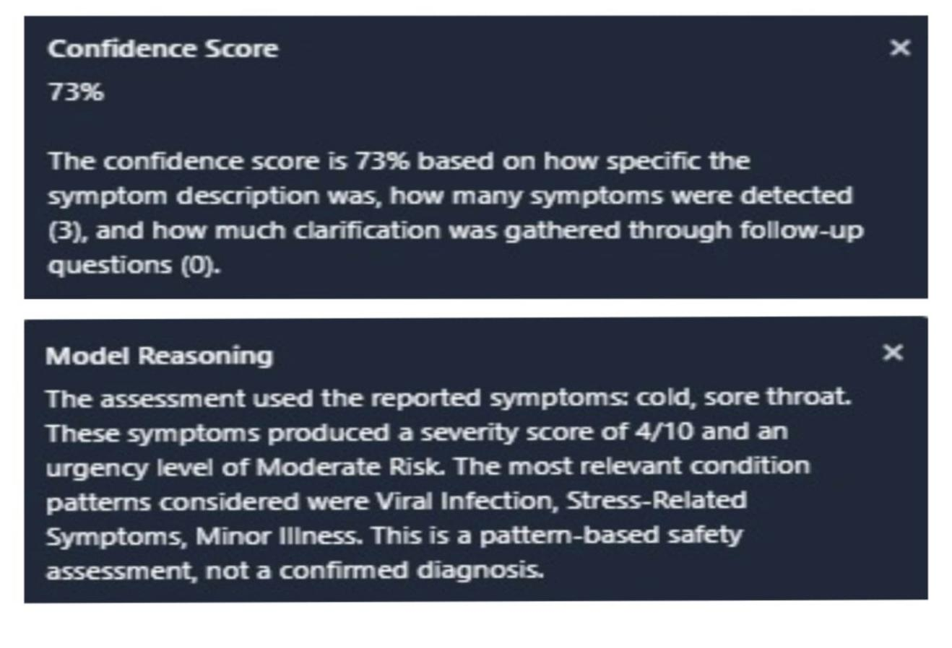
Fig 9.2.2 : Confidence scores and reasoning

Chapter 10
FUTURE ENHANCEMENTS

The HygionX system provides a strong foundation for an AI-based medical triage assistant; however, several enhancements can be incorporated to further improve its capabilities and real-world applicability.
One of the major future enhancements is the integration of advanced domain-specific language models such as BioBERT, ClinicalBERT, or other medical LLMs. These models can improve the system’s ability to understand complex medical queries, interpret user inputs more accurately, and generate more context-aware responses.
Another important enhancement is the incorporation of real-time medical knowledge bases and APIs. By connecting the system to trusted medical sources, the chatbot can provide updated medical information and more accurate recommendations aligned with current healthcare standards.
The system can also be enhanced by supporting multilingual interaction, making it accessible to a wider population and improving usability for users from different linguistic backgrounds.
Personalization can be further improved by incorporating deeper user health profiling, including past medical history, allergies, and previous interactions, enabling more precise and individualized triage results.
Integration with wearable devices and health monitoring systems can further enhance the system by enabling real-time data analysis and early detection of potential health issues.
Additionally, security and privacy can be strengthened by implementing advanced encryption and secure authentication mechanisms to protect sensitive health data.
The system can also be extended to support voice-based interaction, improving accessibility for elderly users and individuals with disabilities.
Finally, integrating telemedicine features such as doctor consultation and appointment booking can transform HygionX into a more comprehensive digital healthcare solution.

Chapter 11
CONCLUSION

The HygionX system successfully demonstrates the application of artificial intelligence in delivering preliminary medical guidance through an interactive, user-friendly chatbot interface. The system is designed to interpret user-reported symptoms, conduct a structured triage process, and generate meaningful health assessments along with appropriate recommendations, thereby improving accessibility to basic healthcare support.
By integrating natural language processing, rule-based logic, and optional machine learning components, HygionX effectively understands user inputs, extracts relevant symptoms, and classifies the level of risk into categories such as low, moderate, high, or emergency. The system maintains conversational context across multiple interactions, enabling more accurate and consistent analysis through follow-up questioning and symptom aggregation.
A key strength of the system lies in its emphasis on explainability and transparency. Along with the triage results, HygionX provides a clear explanation of the reasoning behind its predictions. Additionally, the inclusion of a confidence score for each assessment plays a crucial role in conveying the reliability of the output, allowing users to make informed decisions, especially when professional consultation is recommended.
Furthermore, the system is designed with flexibility and robustness, supporting both ML-assisted and fallback modes to ensure uninterrupted functionality even in resource-constrained environments. Security features such as authentication and controlled data handling further ensure the safe management of sensitive user information.
In conclusion, HygionX serves as a reliable AI-based medical triage assistant that bridges the gap between basic symptom checking and intelligent healthcare support. While it does not replace professional medical diagnosis, it provides valuable preliminary insights, promotes informed decision-making, and contributes to enhancing digital healthcare accessibility and user awareness.

Chapter 12
BIBILOGRAPHY

- Jegadeesan, R., Srinivas, D., Umapathi, N., Karthick, G., & Venkateswaran, N.
(2023). Personal healthcare chatbot for medical suggestions using artificial intelligence and machine learning. European Chemical Bulletin, 12(S3).
- Bickmore, T. W., & Giorgino, T. (2006). Health dialog systems for patients and consumers. Journal of Biomedical Informatics, 39(5), 556–571.
- Laranjo, L., Dunn, A. G., Tong, H. L., et al. (2018). Conversational agents in healthcare: A systematic review. Journal of the American Medical Informatics Association, 25(9), 1248–1258.
- Rajkomar, A., Dean, J., & Kohane, I. (2019). Machine learning in medicine. New England Journal of Medicine, 380(14), 1347–1358.
- Topol, E. (2019). High-performance medicine: The convergence of human and artificial intelligence. Nature Medicine, 25(1), 44–56.
- Devlin, J., Chang, M. W., Lee, K., & Toutanova, K. (2019). BERT: Pre-training of deep bidirectional transformers for language understanding. NAACL-HLT.
- Vaswani, A., Shazeer, N., Parmar, N., et al. (2017). Attention is all you need. Advances in Neural Information Processing Systems (NeurIPS).
- Miner, A. S., Milstein, A., & Hancock, J. T. (2017). Talking to machines about personal mental health problems. JAMA, 318(13), 1217–1218.
- WHO (World Health Organization). (2020). Digital health interventions for health system strengthening.
- FDA (Food and Drug Administration). (2021). Artificial Intelligence and Machine Learning in Software as a Medical Device.
- Chen, M., & Decary, M. (2020). Artificial intelligence in healthcare: An essential guide for health leaders. Healthcare Management Forum, 33(1), 10–18.

- Bibault, J. E., Chaix, B., Guillemassé, A., et al. (2019). A chatbot versus physicians to provide information for patients with breast cancer. Journal of Medical Internet Research, 21(11).
- Denecke, K., et al. (2019). Artificial intelligence for patient support: A review of AI chatbots in healthcare. Health Informatics Journal.
- Shortliffe, E. H., & Sepúlveda, M. J. (2018). Clinical decision support in the era of artificial intelligence. JAMA, 320(21), 2199–2200.
- Jiang, F., Jiang, Y., Zhi, H., et al. (2017). Artificial intelligence in healthcare: Past, present and future. Stroke and Vascular Neurology, 2(4), 230–243.
- Beam, A. L., & Kohane, I. S. (2018). Big data and machine learning in healthcare. JAMA, 319(13), 1317–1318.
- Obermeyer, Z., & Emanuel, E. J. (2016). Predicting the future — Big data, machine learning, and clinical medicine. New England Journal of Medicine, 375(13), 1216– 1219.
- Razzaki, S., Baker, A., Perov, Y., et al. (2018). A comparative study of artificial intelligence and human doctors for triage and diagnosis. npj Digital Medicine, 1(1), 1–8.
- Amisha, Malik, P., Pathania, M., & Rathaur, V. K. (2019). Overview of artificial intelligence in medicine. Journal of Family Medicine and Primary Care, 8(7), 2328– 2331.
- Davenport, T., & Kalakota, R. (2019). The potential for artificial intelligence in healthcare. Future Healthcare Journal, 6(2), 94–98.

